REVIEW
January 2006 to April 2006 Vol. 17 No. 1

Environmental Professionals of Iowa is a multidisciplinary organization that promotes education and standards of conduct and performance in the environmental field. The organization also provides a forum for environmental professionals to express a collective statement and provide a professional perspective on environmental issues.

2006 EPI Officers

Sid Juwarker, President
Phone: 515-256-8814
E-Mail: sjuwarker@barkerlemar.com

Jeff King, Past President
Phone: 800-858-5227
E-Mail: jking@keystonelabs.com

Matt Deutsch, President Elect
Phone: 515-283-0500
E-Mail: mdeutsch@hydro-klean.com

Jasmine Bootman, Secretary
Phone: 515-271-9608
E-Mail: jbootman@gmail.com

Helga Mayhew, Treasurer
Phone: 515-256-8814
E-Mail: hmayhew@barkerlemar.com

Ryan Blackburn, Program Chair
Phone: 515-283-0500
E-Mail: rblackburn@hydro-klean.com

Steve Reinders, Newsletter Editor
Phone: 515-276-8046
E-Mail: reinders@gabrobins.com

Environmental Professionals of Iowa
P.O. Box 65484
West Des Moines, Iowa 50265
www.epiowa.org

President’s Corner
By Sid Juwarker

Time must fly when you’re having fun because I can’t believe another year has gone by. As I begin to reminisce on the memories from the last year, I can say that it has been an exciting one for EPI and its members

Quick Recap of 2005:
- EPI represented its members at the last IDNR week long Kaizen event.
- Our dinner speakers were fantastic and turnout surpassed expectations.
- We conducted a field workshop and received great feedback.
- We had a great symposium turnout in November and experts assure me it had nothing to do with the December CEU deadline.
- The list goes on…

But now its time to stop reminiscing and start thinking of the year ahead. We have some exciting changes in the works.

We have decided to give the EPI website a new look and over the next few months the EPI website will be undergoing an overhaul. It is widely accepted that people practicing in the environmental field in Iowa are a dazzling group of professionals and we’d like our website to reflect that. Our website address is now www.epiowa.org, which is more representative of the kind of organization we are.

Our address has also changed so please update your records. We are now located at:

P.O. Box 65484, West Des Moines, IA 50265.

EPI will be trying to bring in new and exciting speakers for this year’s symposium. We are asking for input from our members to help us put together the best possible line-up of topics and speakers. If you have attended a conference recently and were impressed by a speaker or know of a topic that you would like to learn more about please email any member of the board, and EPI will do our best to bring those speakers/topics to you.

We are also discussing other possibilities such as offering scholarships to environmental students, offering more training workshops as well as coming up with new ways to facilitate more interaction between out members. Your suggestions are always welcome.

I look forward to this upcoming year and hope we can all continue to grow.

________________________________________________________________________________

March Board Meeting

An EPI board meeting was held on March 21, 2006. Those present included:

Sid Juwarker – President
Matt Deutsch – President Elect
Ryan Blackburn – Program Chair
Jasmine Bootman – Secretary
Christy Jaworski – Member

- The content of the spring edition of the EPI newsletter was discussed.

- Planning continued for the upcoming EPI meetings and the Fall 2006 EPI Symposium.

- The next EPI dinner meeting is planned for Thursday, April 20, 2005, at the North End Diner.

- The next EPI Board meeting will be held in June 2006 and will primarily be a planning meeting for the EPI Symposium. Exact date is to be determined. All EPI members are welcome to attend.

________________________________________________________________________________

April Dinner Meeting:
Jeff Hove to speak about E85 Fuel

Speaker: Jeff Hove
Date: April 20, 2006
Time: Social hour starts at 5:30 pm, dinner is served at 6:30 pm
Location: North End Diner, 5050 Merle Hay Road, Johnston, Iowa
Cost: $15

Jeff Hove will discuss the status of E85 fuel in Iowa today. Topics will include environmental liability, current marketability, and equipment compatibility when retailing the renewable fuel. An overview of current legislative progress will be outlined and what this means to retailers and the public discussed.

About the Speaker

Jeff Hove is the Regulatory Affairs Manager for the Petroleum Marketers and Convenience Stores of Iowa located in West Des Moines. He currently sits on the Renewable Fuels Committee which manages Iowa Value Fund money allocated to retailers. This funding has been established by the State to promote E85 availability through safe and compatible equipment which is required under Iowa Code.

Mr. Hove has a BS degree in Hydrogeology/Groundwater Management from the University of Wisconsin, Steven Point. Following several years as an environmental consultant, he worked for the Iowa Underground Storage Tank Fund. He currently sits on committees for the transportation of hazardous materials, renewable fuels, security awareness, and participates in numerous Kaizen Events affecting environmental standards and public safety.

________________________________________________________________________________

Upcoming September 2006 EPI Dinner Meeting
By Christy Jaworski

Don’t forget to put September 21st, 2006, on your calendar! EPI will be having their dinner meeting in Ames and will be touring Iowa State University’s (ISU) new Environmental Health and Safety Services Building. The building is very impressive and has some unique features.

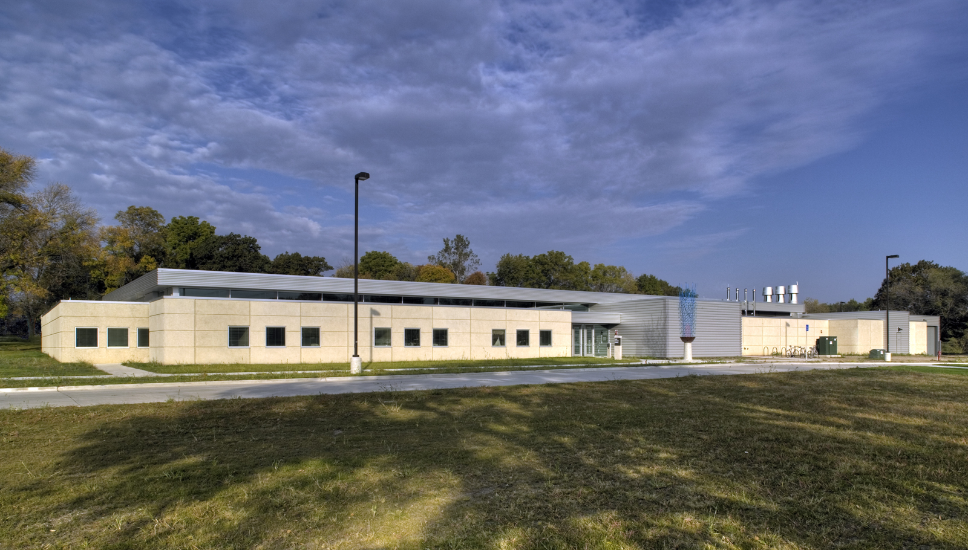
Some statistics on the building:
- 100,000 ft²
- Cost $8.5 M to build
- Multiple fire suppression systems
  - CO2, Foam, Dry and Wet Sprinkler
- Secondary and tertiary containment systems
- Alarms system for tornado, fire, chemical and low explosive limit

Some of the unique features of this building include:
- Compartmentalized hazards
- Maximal distance between incompatibles
- Optimized quantities
- Traffic flow in building

Containment
- Spills
  - Each cell provides containment for one or two 55-gal drum (+10%) spill
  - Floors have a gradual slope away from door
  - Floors have an impervious resin coating
  - Drains are located on the high side

- Fire Suppression
  - Drains located in each cell
  - Underground Collection Tanks

- Overflow runs into detention pond

Please plan on joining us and finding out more about this unique building!

________________________________________________________________________________

EPI Tip of the Day

“When sampling using 40mL vials on a windy day use a 2” slip cap to hold the vials. Three vials fit perfectly in a 2” slip cap and won’t tip over.” (Anonymous tipster)

TIPS
Got a better way of doing things in the field or in the office? Send a brief explanation by email to the EPI newsletter editor for publication in the newsletter. The person who provided the tip that is selected for the next newsletter will be awarded a $10 gift card.

________________________________________________________________________________

Calendar of Events

4/20 EPI Dinner Meeting 6PM at North End Diner.
4/22 Earth Day
6/? EPI Board Meeting, 6PM at HydroKlean. (Date to be determined.)
8/08 EPI Board Meeting, 6PM at HydroKlean.
9/21 EPI Dinner Meeting and tour of ISU Environmental Health and Safety Services Building
11/15 - 11/16 EPI Symposium

** If there are any questions about upcoming EPI events please feel free to contact an EPI officer.**

________________________________________________________________________________

Has your Membership Expired?

Environmental Professionals of Iowa – Membership Form
Name |  |  |  |  |  |  |  |  |  |  |  |  |  |  |  |  |  |  |  | Please check all that apply:
Company/Org. |  |  |  |  |  |  |  |  |  |  |  |  |  |  |  |  |  |  |  | ◻ New Member
Title/Position |  |  |  |  |  |  |  |  |  |  |  |  |  |  |  |  |  |  |  | ◻ Renewal Member
Address |  |  |  |  |  |  |  |  |  |  |  |  |  |  |  |  |  |  |  | ◻ Individual ($25.00)
 |  |  |  |  |  |  |  |  |  |  |  |  |  |  |  |  |  |  |  | ◻ Corporate ($150.00)
City |  |  |  |  |  |  |  |  |  | State |  |  |  |  |  |  | Zip |  |  | Includes two individual memberships
Phone |  |  |  |  |  |  |  |  |  |  | Fax |  |  |  |  |  |  |  |  | ◻ Student ($15.00)
E-Mail |  |  |  |  |  |  |  |  |  |  |  |  |  |  |  |  |  |  |  | School
Mail Membership Form to: |  |  |  |  |  |  |  |  |  |  |  |  |  | EPI
 |  |  |  |  |  |  |  |  |  |  |  |  | P.O. Box 65484
 |  |  |  |  |  |  |  |  |  |  |  |  | West Des Moines, IA 50265

